Rights and Permissions Guidelines for the Book Arts
By Suzanne Glémot

At its most basic, publishing is the activity of making information available to the public; it is the dissemination of information into the world. Letterpress printing, digital printing, and works of calligraphy are all forms of publishing. It is the responsibility of artists and makers working within these modes of production to secure proper copyright permissions for publishing texts (or images) that are not originally their own. This responsibility extends to academic projects that are not necessarily also commercial endeavors.
The general consensus when it comes to intellectual property and copyright is that it is better to seek permission than to ask for forgiveness. This document is intended to function as a resource for artists and students working in the book arts and looking to obtain permissions for use of materials from publishers and/or copyright owners. Included in these guidelines is a form letter that can be adapted to the specific permissions needs of book and broadside projects. The form is designed primarily for one-time, non-exclusive text permissions in studio-based projects, but can be modified to fit other rights requests and to reach out to authors, artists, or other rights holders.

❧ Where do I start?
The University of Chicago Press offers an excellent website explaining copyright and permissions. Like any area of practice, permissions can get a little technical at times, but this resource is a great primer on the world of rights and permissions.
A good first place to look when ascertaining who to contact about text permissions is the copyright page of the book with which you are working (assuming you are pulling text from a book). Alternatively, online search engines can be a useful source of information.

❧ Do I need to secure permission for use?
Depending on the nature of the text under consideration, the question may arise as to whether permissions are even needed in order to publish. Below are a few scenarios you might encounter in your research:
If you text if in the Public Domain, good news: text, images, or documents that are in the Public Domain do not require permissions clearances for use. As of 2020, the Public Domain in the U.S. generally includes work that was published before January 1, 1925. Note: Even if the text you are using is in the Public Domain, you may want to offer acknowledgments as to the provenance of the text somewhere in your work. For more on the Public Domain, check out these pages by the Stanford University Libraries and Cornell University Library.
If the text you are using is not in the Public Domain, a good way to start answering whether you need to secure permission is to analyze your found text through the lens of the Fair Use Doctrine. The Fair Use Doctrine is what allows us, for example, to include citations in academic papers without needing a publisher’s permission. Note that Fair Use is not a free pass for dealing with permissions — you have to prove and justify fair use of material in your process.
Beyond the Public Domain and Fair Use, here is a good rule of thumb: if you are going to sell anything containing material not originally yours and that is still under copyright, you definitely need to secure permissions. If your work with this text is purely for academic/class/educational purposes, you are not bound to request permission — though doing so is a gesture of good faith from one creator to another, and a way to formally acknowledge the presence of outside text in your own work.
❧ NB: if you are using found text to proof type or to practice a hand in calligraphy and you are certain that these exercises will never see the light of day, then you do not need to be so concerned with permissions.

❧ Are there special cases in permissions that I should keep in mind?
Certain parts of artist books, such as epigraphs and block quotations, absolutely do require permissions clearance if the text is not in the Public Domain. The University of Texas Press has some good information about epigraphs.
The nature of music/lyric permissions is such that the process can take a little more time than securing permissions for, say, a poem (and it can be a little costly, too). Getting permission for such material requires searching through the websites of three main music publishers (BMI, SESAC, and ASCAP) to figure out which of them might own the rights, and then contacting them for use. In your search for the correct party to contact, remember that there can be a distinction between the rights to the composition itself and the rights to a particular recording. Here are a couple of additional resources on music and epigraph permissions you might want to check out: Virginia Lloyd’s website and a page by the Copyright Society of the USA.
This does not happen often, but do keep an eye out for copyright renewal notices, which can apply to works created before January 1, 1978 (for more information, see the U.S. Copyright Office website on the subject).
Also, bear in mind that translations of texts are protected by their own copyright. For example, a 200-year-old translation of the Bible might be in the Public Domain, but if the version of a verse you’d like to print is from a newly translated edition published 5 years ago, you will need to secure permission to print that particular version of the verse.

❧ I need to obtain permission to publish a text. How do I go about this?
Major commercial publishers and university presses often have pre-set online forms designed to collect and process specific types of permissions requests. These forms do not always do a good job at capturing the permissions needs for work in the book arts, so reaching out directly to the appropriate email address with specific information about your intended use of the material may save you a lot of time. For this, you can use the form letter on page 6. Keep in mind that things can move pretty slowly in the permissions world and that it is a good idea to get your permission request in as early as you are able, at least 4-6 weeks.
A significant point of distinction: academic project vs. commercial project. If your use of text is strictly academic (i.e.: you are making the work for class and will not be selling any of the copies you produce at any time), then you could request that the permission you are seeking be granted to you at no cost (“gratis”). If your intention is commercial in any capacity (which you will be asked to clarify in your request), be prepared to budget and pay for a licensing/use fee.
On the studio art side of academia, showing work in exhibitions is considered an equivalent activity to traditional academic publishing (i.e.: publishing an article in a scientific journal). As such, it could be considered that showing work in a public or private venue is an extension of the publishing activity for which you obtained permission to reprint a text or an image, and is thus covered by the permission you obtained. Remember, however, that depending on the terms of the permission that was granted to you, you may or may not be able to sell your piece through the exhibition (a sale is a sale, no matter the context in which you make it).

A note about this document:
I designed this document to support artists and makers in obtaining permission for text-based projects. I hope that you will share it in educational and artistic settings as you find useful. I only ask that you acknowledge the source of this material in an appropriate fashion.
In compiling this resource, I drew from my work as a Rights and Permissions Manager for a small university press. Please do not take any of this as legal advice; consult your fellow artists, your librarians, and your local volunteer lawyers for the arts organizations if you need additional support in your work.
A huge thanks to David Bright at Iowa Volunteer Lawyers for the Arts for looking over this document. My classmate Rich Dana (University of Iowa UICB+SLIS) offered the University of Chicago Press link as a valuable resource.

Happy making!

Suzanne Glémot
www.suzanneglemot.com

October 2019
February 2021 — revised

Permissions Request Form Letter - INSTRUCTIONS

- All of the text enclosed in square brackets and highlighted in yellow [for example] is for you to fill in or insert into the body of the message according to your specific permissions needs;

- If your Rights Requested and/or Proposed Use sections vary from what is described in the template, do your research and modify them accordingly (for example, below is a screenshot of how these details are categorized and captured by the University of Iowa Press’ Rights & Permissions Request Form).

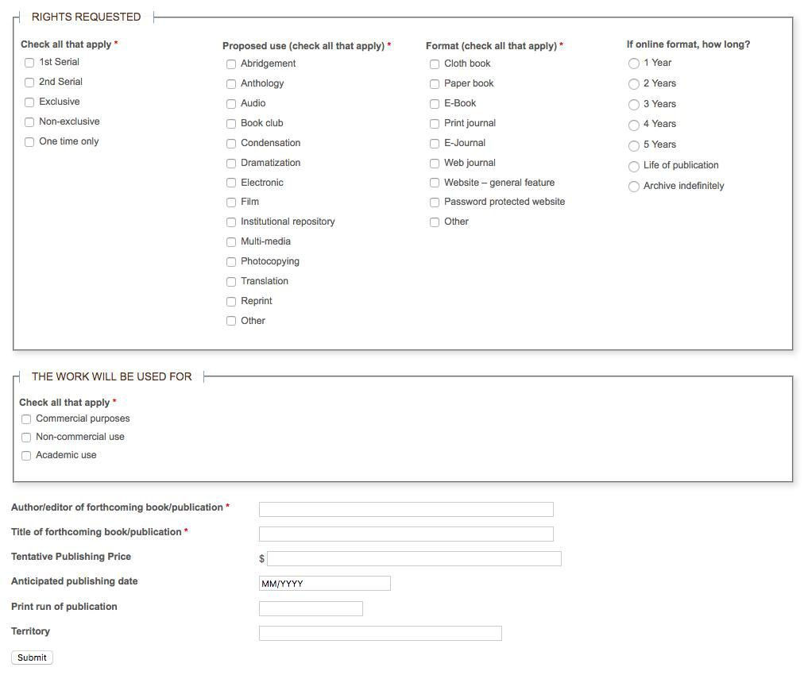

From: https://www.uipress.uiowa.edu/contact/rights-and-permissions-request
FILLABLE FORM LETTER/ EMAIL

To: [permissions@publisher.com]

Subject: Permissions Request: [Title] ([Author Last Name])

Body: Dear Rights and Permissions Manager,

I am a [student] in [subject] at [institution] ([program website, if applicable]). I seek permission to [hand-print/ digitally print/ hand letter/ use] [description of text for which you are seeking permission] from [title of work] by [author’s name] in [description of your work], to be [produced by hand/ letterpress printed] in an edition of [number of copies].

I am including details of my project below, in the hopes of facilitating this request:

[Please note that due to the academic nature of this project/ and in consideration of the minimal amount of material requested/ I would like to ask that this permission be granted gratis.]

Author of work: [---]
Year published: [---]
Title of work: [---]
ISBN: [---]
Material being requested from book: [reference it as it appears in the publication, including (if applicable) page range, beginning text, and ending text]

REQUESTOR INFORMATION
Name: [name of person making request]
Address: [---]
City: [---]
State: [---]
Zip: [---]
Country: [---]
Email: [---]
Phone: [---]

PUBLISHER INFORMATION
Name: [name of publisher (your name or press name)]
Address: [---]
City: [---]
State: [---]
Zip: [---]
Country: [---]
Purpose: [---]
Phone: [---]
Email: [---]
Website URL: [---]

RIGHTS REQUESTED
Non-exclusive
One time only
English language
World rights

Proposed use: Reprint

Use: [commercial/ non-commercial/ academic]

Format: [artist book titled [---], by [---], in an edition of [---] copies, to be
completed [anticipated date]]

[I would be happy to provide [publisher or rights-holder name] with one or two copies of my finished work, should this permission be granted with such terms]. Please indicate your preferred form for acknowledgments or credits. If you are not the person to whom I need to address this request, please let me know who I may better contact instead.

With regards,

[name]
--
[email signature]

SAMPLE LETTER/ EMAIL

To: permissions@penguinrandomhouse.com

Subject: Permissions Request: The Bluest Eye (Morrison)

Body: Dear Rights and Permissions Manager,

I am an MFA candidate in the Book Arts at the University of Iowa Center for the Book. I seek permission to hand-print the first sentence of Toni Morrison's The Bluest Eye in a small artist book that I am producing this month from handmade papers and handset metal type, in a very small edition of up to 30 copies. This 6-page booklet will feature original prints of marigolds, which I’ve designed to accompany the line that inspired this project: “Quiet as it's kept, there were no marigolds in the fall of 1941.”

I am including details of my project below, in the hopes of facilitating this request:

Please note that due to the academic nature of this project, and in consideration of the minimal amount of material requested, I would like to ask that this permission be granted gratis.

Author of work: Toni Morrison
Year published: 2007
Title of work: The Bluest Eye
ISBN: 978-0307278449
Material being requested from book: the sentence “Quiet as it's kept, there were no marigolds in the fall of 1941.” (found on page 5 of the Vintage International edition).

REQUESTOR INFORMATION
Name: Suzanne Glémot
Address: [address redacted]
City: Iowa City
State: IA
Zip: 52245
Country: United States of America
Email: suzanne-glemot@uiowa.edu
Phone: [number redacted]

PUBLISHER INFORMATION
Name: Suzanne Glémot
Address: [redacted]
City: Iowa City
State: IA
Zip: 52245
Country: United States of America
Purpose: for inclusion in a hand-printed and hand-bound artist book
Phone: [redacted]
Email: suzanne-glemot@uiowa.edu
Website URL: https://www.suzanneglemot.com/

RIGHTS REQUESTED
Non-exclusive
One time only
English language

Proposed use: Reprint

Use: academic/ non-commercial purposes only

Format: artist book in an edition of 30 hand-printed copies

I would be happy to provide Penguin Random House with one or two copies of my finished work should this permission be granted and should you request it in your terms. Please indicate your preferred form for acknowledgments or credits, if any. If you are not the person to whom I need to address this request, please let me know who I may better contact instead.

With best regards,

Suzanne
--
Suzanne Glémot
MFA Candidate, Book Arts
University of Iowa Center for the Book

“Author’s Permission Guidelines,” The University of Chicago Press (University of Chicago), accessed February 23, 2021, https://www.press.uchicago.edu/infoServices/permissions.html.
Stim, Richard. “Welcome to the Public Domain.” Stanford Copyright and Fair Use Center. Stanford University Libraries, December 4, 2019. https://fairuse.stanford.edu/overview/public-domain/welcome/.
“Copyright Term and the Public Domain in the United States.” Copyright Information Center. Cornell University Library. Accessed February 23, 2021. https://copyright.cornell.edu/publicdomain.
U.S. Copyright Office. “More Information on Fair Use.” U.S. Copyright Office. Library of Congress. Accessed February 23, 2021. https://www.copyright.gov/fair-use/more-info.html.
“Prospective Author Guidelines.” The University of Texas Press. University of Texas, September 29, 2020. https://utpress.utexas.edu/authors#Epigraphs.
“Broadcast Music, Inc. (BMI).” BMI.com. Broadcast Music, Inc. Accessed February 23, 2021. https://www.bmi.com/.
SESAC. The Society of European Stage Authors and Composers. Accessed February 23, 2021. https://www.sesac.com/#/.
“ASCAP.” www.ascap.com. The American Society of Composers, Authors and Publishers. Accessed February 23, 2021. https://www.ascap.com/.
Lloyd, Virginia. “Using Lyrics or an Epigraph in Your Book? Curious about Copyright?” Virginia Lloyd, October 4, 2020. https://virginialloyd.com/using-lyrics-or-an-epigraph-in-your-book-curious-about-copyright/.
Getting Permission. The Copyright Society of the U.S.A. Accessed February 23, 2021. http://www.copyrightkids.org/permissioninformation.htm.
U.S. Copyright Office. “How Long Does Copyright Protection Last?” U.S. Copyright Office. Library of Congress. Accessed February 23, 2021. https://www.copyright.gov/help/faq/faq-duration.html.

